WEEK 4

Spring REST using Spring Boot 3

**Hands on 1**

**Create a Spring Web Project using Maven**

**CODE:**

**SpringLearnApplication.java**

package com.cognizant.spring_learn;

import org.springframework.boot.SpringApplication;

import org.springframework.boot.autoconfigure.SpringBootApplication;

@SpringBootApplication

public class SpringLearnApplication {

public static void main(String[] args) {

SpringApplication.run(SpringLearnApplication.class, args);

System.out.println("Spring Boot App started successfully");

}

}

**OUTPUT:**

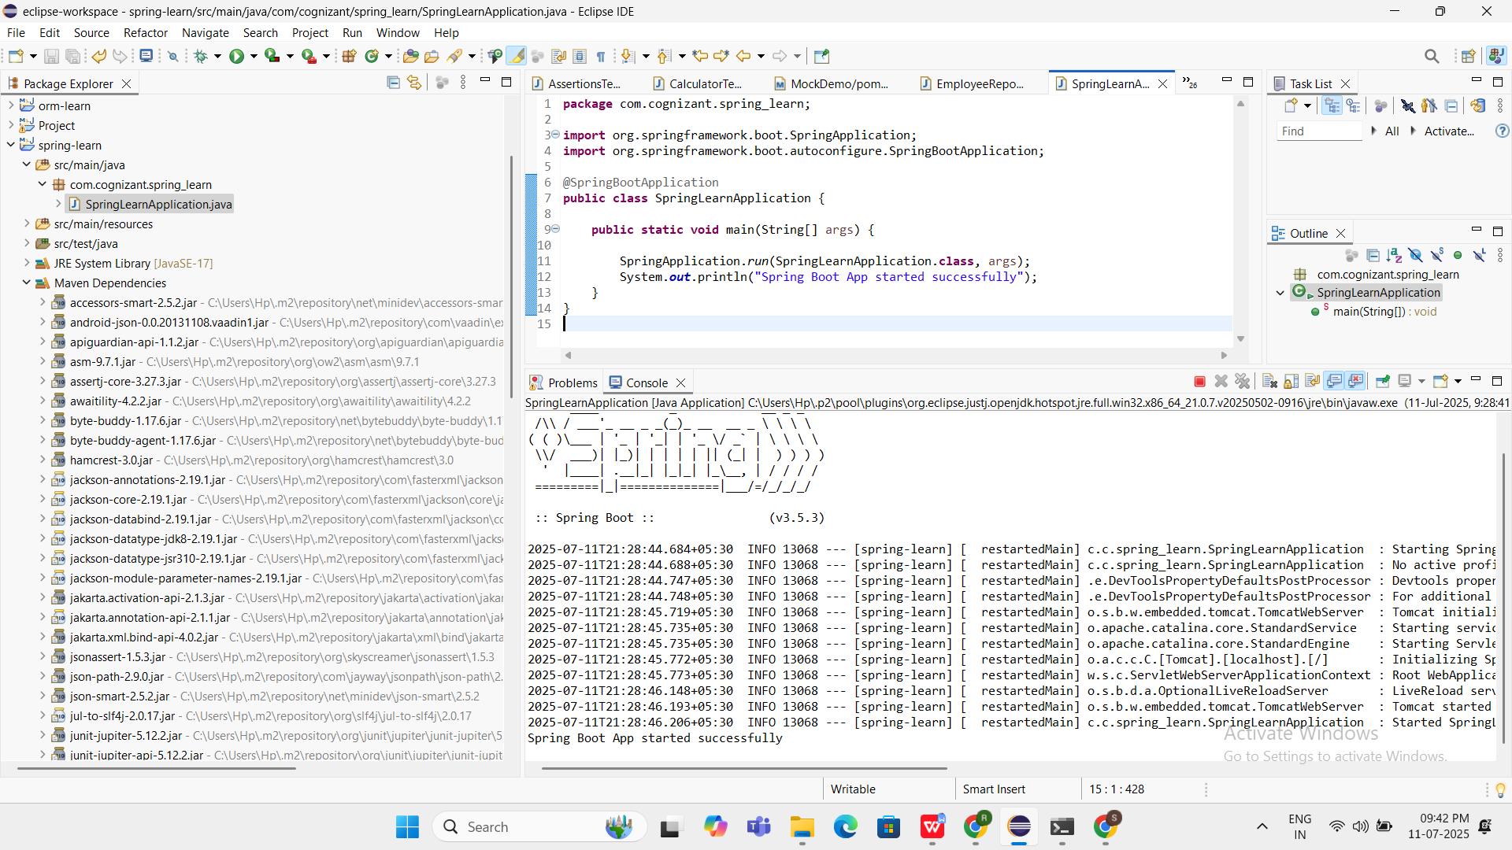

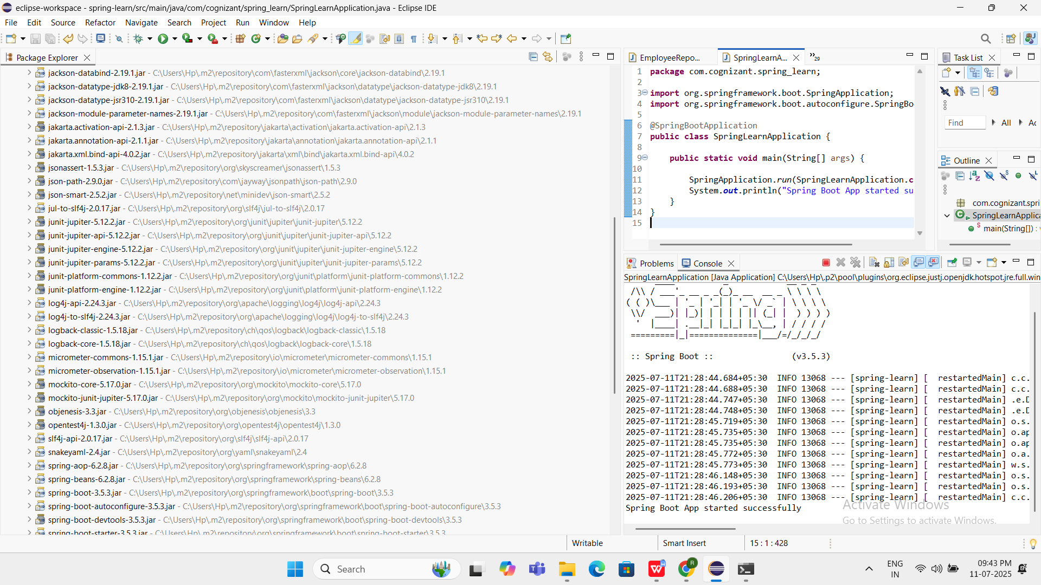

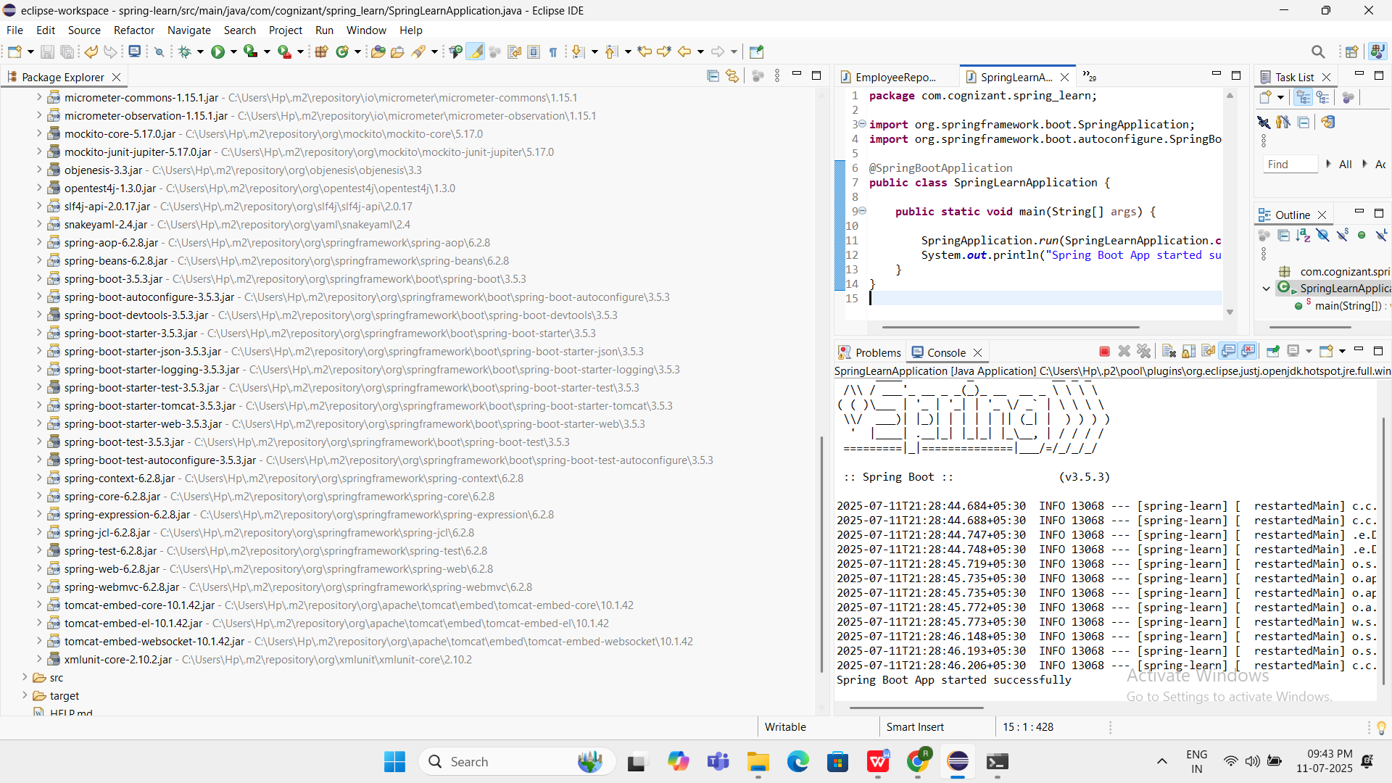

Maven Dependencies are Shown

**Hands on 4**

**Spring Core – Load Country from Spring Configuration XML** 

CODE:

**country.xml**

<?xml version="1.0" encoding="UTF-8"?>

<beans xmlns="http://www.springframework.org/schema/beans"

xmlns:xsi="http://www.w3.org/2001/XMLSchema-instance"

xsi:schemaLocation="

http://www.springframework.org/schema/beans

http://www.springframework.org/schema/beans/spring-beans.xsd">

<bean id="country" class="com.cognizant.spring_learn.Country">

<property name="code" value="IN"/>

<property name="name" value="India"/>

</bean>

</beans>

**Country.java**

package com.cognizant.spring_learn;

public class Country {

private String code;

private String name;

public Country() {

System.out.println("Inside Country Constructor.");

}

public String getCode() {

System.out.println("Inside getCode()");

return code;

}

public void setCode(String code) {

System.out.println("Inside setCode()");

this.code = code;

}

public String getName() {

System.out.println("Inside getName()");

return name;

}

public void setName(String name) {

System.out.println("Inside setName()");

this.name = name;

}

@Override

public String toString() {

return "Country [code=" + code + ", name=" + name + "]";

}

}

**SpringLearnApplication.java**

package com.cognizant.spring_learn;

import org.springframework.context.support.ClassPathXmlApplicationContext;

public class SpringLearnApplication {

public static void main(String[] args) {

System.out.println("START");

displayCountry();

System.out.println("END");

}

public static void displayCountry() {

try (ClassPathXmlApplicationContext context = new ClassPathXmlApplicationContext("country.xml")) {

Country country = context.getBean("country", Country.class);

System.out.println("Country: " + country);

}

}

}

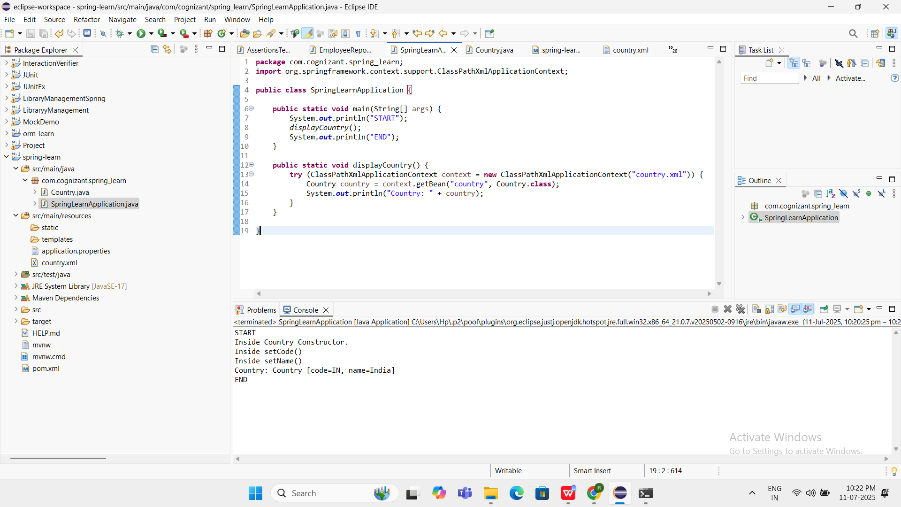

**Hello World RESTful Web Service** 

CODE:

**HelloController.java**

package com.cognizant.spring_learn.controller;

import org.slf4j.Logger;

import org.slf4j.LoggerFactory;

import org.springframework.web.bind.annotation.GetMapping;

import org.springframework.web.bind.annotation.RestController;

@RestController

public class HelloController {

private static final Logger LOGGER = LoggerFactory.getLogger(HelloController.class);

@GetMapping("/hello")

public String sayHello() {

LOGGER.info("START sayHello()");

String message = "Hello World!!";

LOGGER.info("END sayHello()");

return message;

}

}

**SpringLearnApplication.java**

package com.cognizant.spring_learn;

import org.springframework.boot.SpringApplication;

import org.springframework.boot.autoconfigure.SpringBootApplication;

@SpringBootApplication

public class SpringLearnApplication {

public static void main(String[] args) {

SpringApplication.run(SpringLearnApplication.class, args);

}

}

OUTPUT:

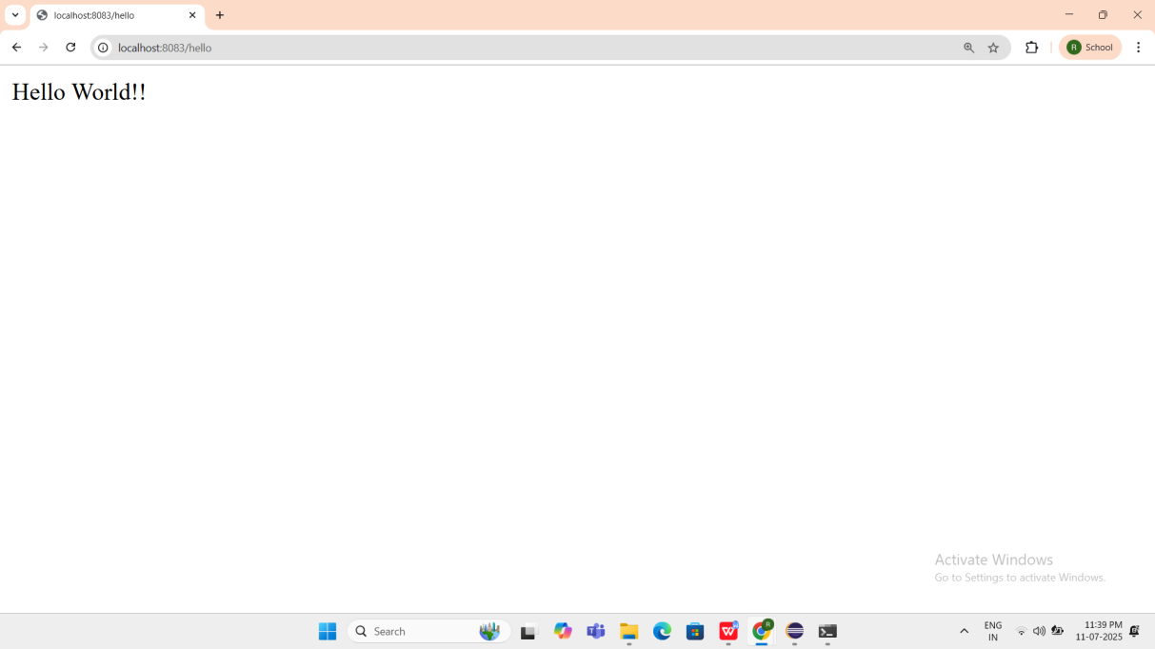

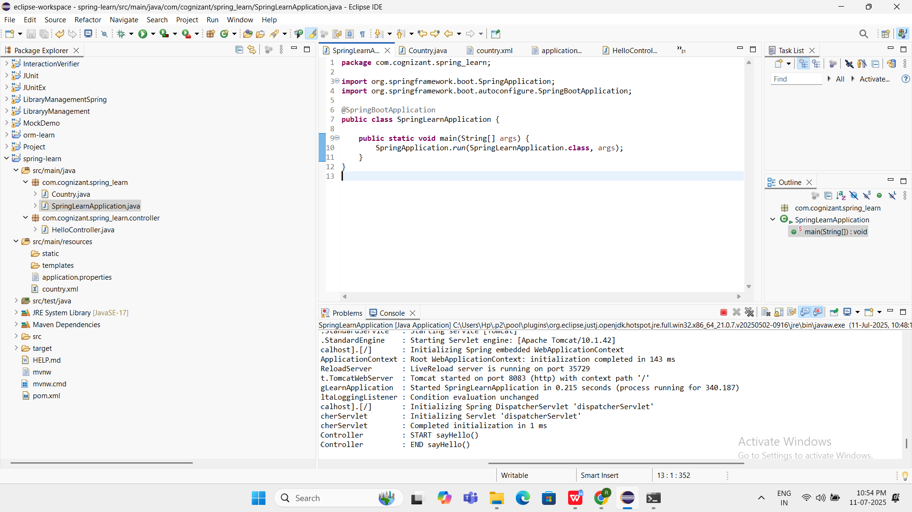

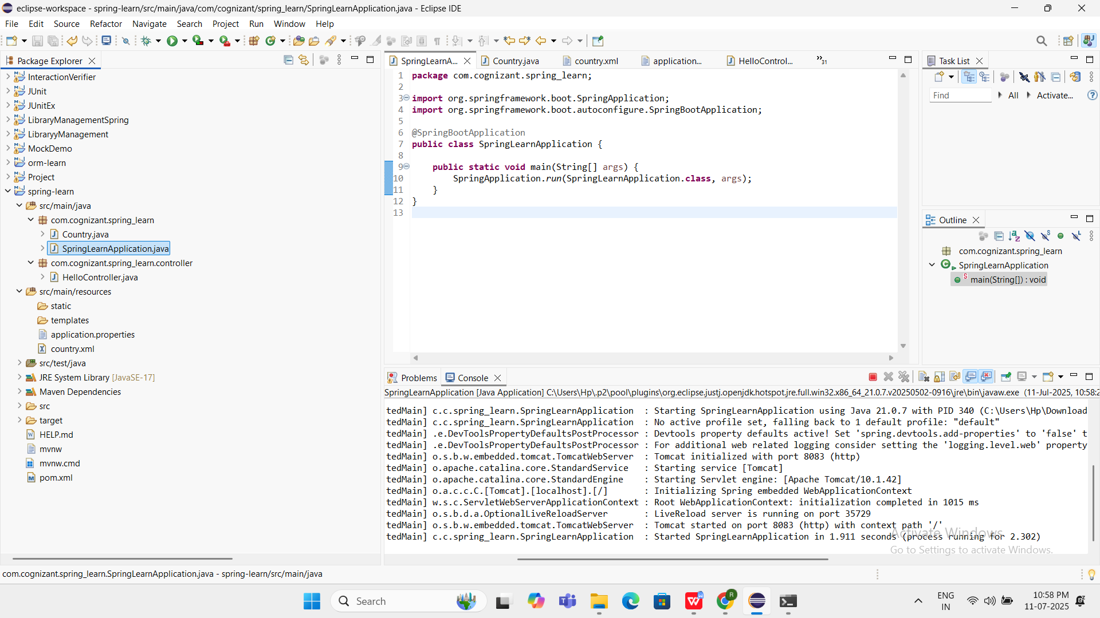

**REST - Country Web Service**

CODE:

**country.xml**

<?xml version="1.0" encoding="UTF-8"?>

<beans xmlns="http://www.springframework.org/schema/beans"

xmlns:xsi="http://www.w3.org/2001/XMLSchema-instance"

xsi:schemaLocation="

http://www.springframework.org/schema/beans

http://www.springframework.org/schema/beans/spring-beans.xsd">

<bean id="in" class="com.cognizant.spring_learn.Country">

<property name="code" value="IN"/>

<property name="name" value="India"/>

</bean>

</beans>

**CountryController.java**

package com.cognizant.spring_learn.controller;

import com.cognizant.spring_learn.Country;

import org.slf4j.Logger;

import org.slf4j.LoggerFactory;

import org.springframework.context.ApplicationContext;

import org.springframework.context.support.ClassPathXmlApplicationContext;

import org.springframework.web.bind.annotation.RequestMapping;

import org.springframework.web.bind.annotation.RestController;

@RestController

public class CountryController {

private static final Logger LOGGER = LoggerFactory.getLogger(CountryController.class);

@RequestMapping("/country")

public Country getCountryIndia() {

LOGGER.debug("START getCountryIndia");

ApplicationContext context = new ClassPathXmlApplicationContext("country.xml");

Country country = context.getBean("in", Country.class);

LOGGER.debug("Country : {}", country.toString());

LOGGER.debug("END getCountryIndia");

return country;

}

}

**Country.java**

package com.cognizant.spring_learn;

public class Country {

private String code;

private String name;

public String getCode() {

return code;

}

public void setCode(String code) {

this.code = code;

}

public String getName() {

return name;

}

public void setName(String name) {

this.name = name;

}

@Override

public String toString() {

return "Country [code=" + code + ", name=" + name + "]";

}

}

OUTPUT:

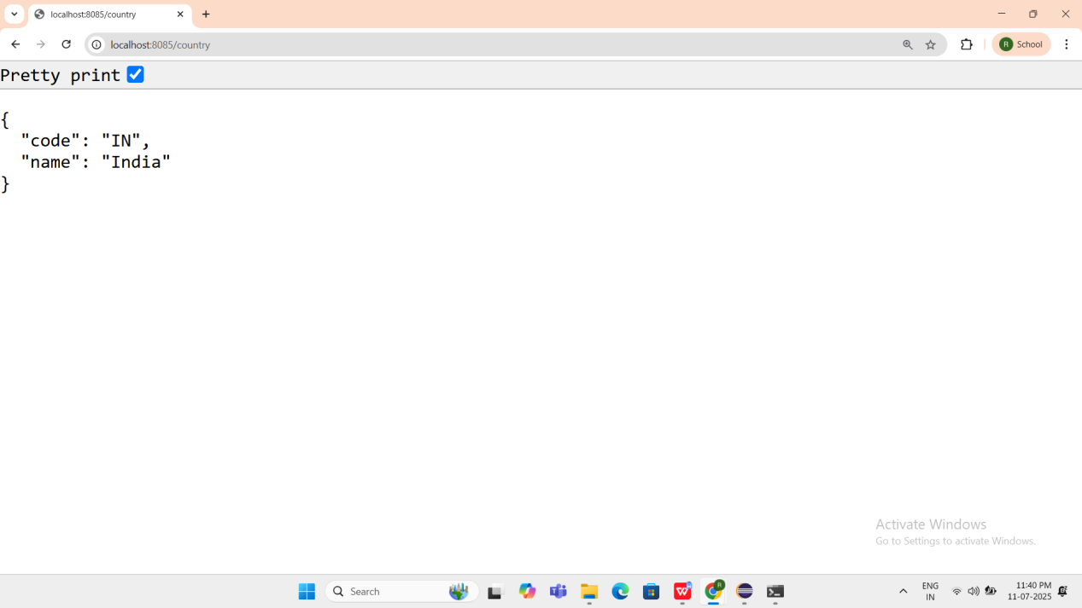  
  
  
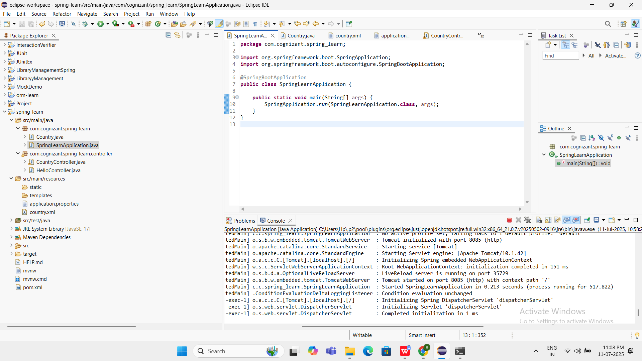

**REST - Get country based on country code**

CODE:

**Country.xml**

<?xml version="1.0" encoding="UTF-8"?>

<beans xmlns="http://www.springframework.org/schema/beans"

xmlns:xsi="http://www.w3.org/2001/XMLSchema-instance"

xsi:schemaLocation="

http://www.springframework.org/schema/beans

https://www.springframework.org/schema/beans/spring-beans.xsd">

<bean id="countryList" class="java.util.ArrayList">

<constructor-arg>

<list>

<bean class="com.cognizant.spring_learn.Country">

<property name="code" value="IN"/>

<property name="name" value="India"/>

</bean>

<bean class="com.cognizant.spring_learn.Country">

<property name="code" value="US"/>

<property name="name" value="United States"/>

</bean>

<bean class="com.cognizant.spring_learn.Country">

<property name="code" value="DE"/>

<property name="name" value="Germany"/>

</bean>

<bean class="com.cognizant.spring_learn.Country">

<property name="code" value="JP"/>

<property name="name" value="Japan"/>

</bean>

</list>

</constructor-arg>

</bean></beans>

**Country.java**

package com.cognizant.spring_learn;

public class Country {

private String code;

private String name;

public String getCode() {

return code;

}

public void setCode(String code) {

this.code = code;

}

public String getName() {

return name;

}

public void setName(String name) {

this.name = name;

}

}

**CountryController.java**

package com.cognizant.spring_learn.controller;

import com.cognizant.spring_learn.Country;

import com.cognizant.spring_learn.service.CountryService;

import org.springframework.beans.factory.annotation.Autowired;

import org.springframework.web.bind.annotation.*;

@RestController

public class CountryController {

@Autowired

private CountryService countryService;

@GetMapping("/countries/{code}")

public Country getCountry(@PathVariable String code) {

System.out.println("START");

Country country = countryService.getCountry(code);

System.out.println("END");

return country;

}

}

**CountryService.java**

package com.cognizant.spring_learn.service;

import com.cognizant.spring_learn.Country;

import org.springframework.context.ApplicationContext;

import org.springframework.context.support.ClassPathXmlApplicationContext;

import org.springframework.stereotype.Service;

import java.util.List;

@Service

public class CountryService {

public Country getCountry(String code) {

ApplicationContext context = new ClassPathXmlApplicationContext("country.xml");

List<Country> countryList = context.getBean("countryList", List.class);

return countryList.stream()

.filter(c -> c.getCode().equalsIgnoreCase(code))

.findFirst()

.orElse(null);

}

}

SpringLearnApplication.java

package com.cognizant.spring_learn;

import org.springframework.boot.SpringApplication;

import org.springframework.boot.autoconfigure.SpringBootApplication;

@SpringBootApplication

public class SpringLearnApplication {

public static void main(String[] args) {

SpringApplication.run(SpringLearnApplication.class, args);

}

}

OUTPUT:

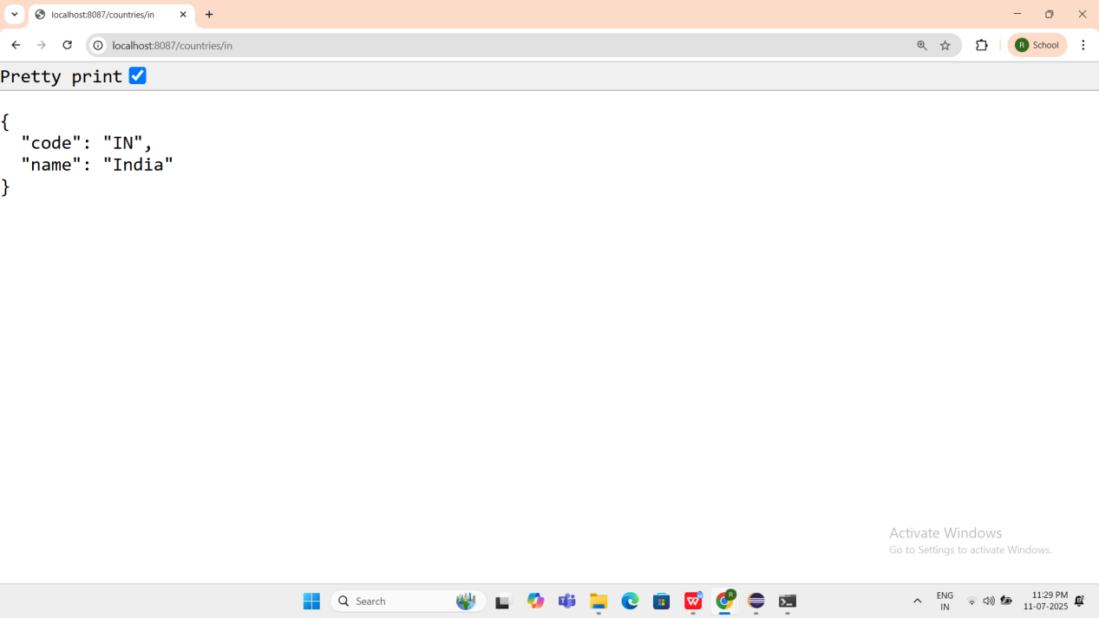

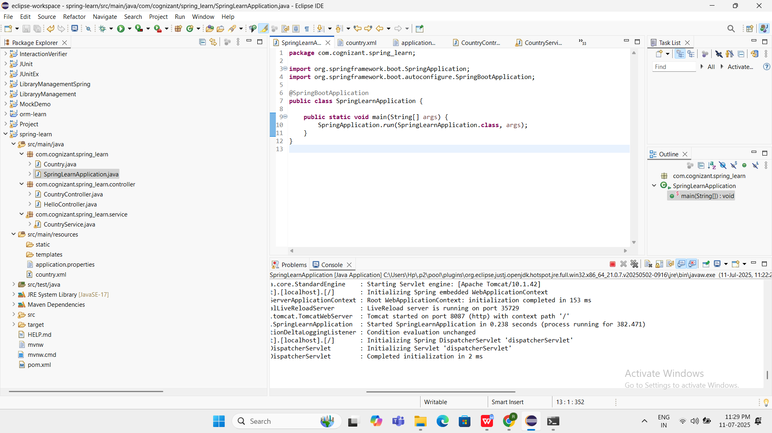

JWT-handson

Create authentication service that returns JWT

CODE:

**JwtauthenticationApplication.java**

package com.example.jwtauthentication;

import org.springframework.boot.SpringApplication;

import org.springframework.boot.autoconfigure.SpringBootApplication;

@SpringBootApplication

public class JwtauthenticationApplication {

public static void main(String[] args) {

SpringApplication.run(JwtauthenticationApplication.class, args);

}

}

**SecurityConfig.java**

package com.example.jwtauthentication.config;

import org.springframework.context.annotation.Bean;

import org.springframework.context.annotation.Configuration;

import org.springframework.security.config.annotation.web.builders.HttpSecurity;

import org.springframework.security.core.userdetails.User;

import org.springframework.security.core.userdetails.UserDetailsService;

import org.springframework.security.provisioning.InMemoryUserDetailsManager;

import org.springframework.security.web.SecurityFilterChain;

@Configuration

public class SecurityConfig {

@Bean

public SecurityFilterChain filterChain(HttpSecurity http) throws Exception {

http.csrf().disable()

.authorizeHttpRequests()

.anyRequest().authenticated()

.and()

.httpBasic();

return http.build();

}

@Bean

public UserDetailsService userDetailsService() {

return new InMemoryUserDetailsManager(

User.withDefaultPasswordEncoder()

.username("user")

.password("pwd")

.roles("USER")

.build()

);

}

}

**AuthenticationController.java**

package com.example.jwtauthentication.controller;

import org.springframework.http.HttpHeaders;

import org.springframework.http.ResponseEntity;

import org.springframework.web.bind.annotation.*;

import java.util.Base64;

@RestController

public class AuthenticationController {

@GetMapping("/authenticate")

public ResponseEntity<?> authenticate(@RequestHeader(HttpHeaders.AUTHORIZATION) String authHeader) {

try {

// Check if header starts with Basic

if (authHeader == null || !authHeader.startsWith("Basic ")) {

return ResponseEntity.status(401).body("Missing or invalid Authorization header");

}

// Decode base64 encoded username:password

String base64Credentials = authHeader.substring("Basic ".length());

byte[] decodedBytes = Base64.getDecoder().decode(base64Credentials);

String credentials = new String(decodedBytes);

String[] values = credentials.split(":", 2);

String username = values[0];

String password = values[1];

// Dummy check (replace with actual validation later)

if ("user".equals(username) && "pwd".equals(password)) {

// Generate dummy JWT token (for now)

String fakeJwt = "eyJhbGciOiJIUzI1NiJ9.fake.jwt.token";

return ResponseEntity.ok().body("{\"token\":\"" + fakeJwt + "\"}");

} else {

return ResponseEntity.status(401).body("Invalid credentials");

}

} catch (Exception e) {

return ResponseEntity.status(500).body("Error: " + e.getMessage());

}

}

}

**JwtUtil.java**

package com.example.jwtauthentication.util;

import io.jsonwebtoken.Jwts;

import io.jsonwebtoken.SignatureAlgorithm;

import org.springframework.stereotype.Component;

import java.util.Date;

@Component

public class JwtUtil {

private final String SECRET_KEY = "secretkey123";

public String generateToken(String username) {

long now = System.currentTimeMillis();

return Jwts.builder()

.setSubject(username)

.setIssuedAt(new Date(now))

.setExpiration(new Date(now + 1000 * 60 * 60)) // valid for 1 hour

.signWith(SignatureAlgorithm.HS256, SECRET_KEY)

.compact();

}

}

**pom.xml**

<?xml version="1.0" encoding="UTF-8"?>

<project xmlns="http://maven.apache.org/POM/4.0.0" xmlns:xsi="http://www.w3.org/2001/XMLSchema-instance"

xsi:schemaLocation="http://maven.apache.org/POM/4.0.0 https://maven.apache.org/xsd/maven-4.0.0.xsd">

<modelVersion>4.0.0</modelVersion>

<parent>

<groupId>org.springframework.boot</groupId>

<artifactId>spring-boot-starter-parent</artifactId>

<version>3.5.3</version>

<relativePath/> <!-- lookup parent from repository -->

</parent>

<groupId>com.example</groupId>

<artifactId>jwtauthentication</artifactId>

<version>0.0.1-SNAPSHOT</version>

<name>jwtauthentication</name>

<description>Demo project for Spring Boot</description>

<url/>

<licenses>

<license/>

</licenses>

<developers>

<developer/>

</developers>

<scm>

<connection/>

<developerConnection/>

<tag/>

<url/>

</scm>

<properties>

<java.version>17</java.version>

</properties>

<dependencies>

<dependency>

<groupId>org.springframework.boot</groupId>

<artifactId>spring-boot-starter-security</artifactId>

</dependency>

<dependency>

<groupId>org.springframework.boot</groupId>

<artifactId>spring-boot-starter-web</artifactId>

</dependency>

<dependency>

<groupId>org.springframework.boot</groupId>

<artifactId>spring-boot-starter-test</artifactId>

<scope>test</scope>

</dependency>

<dependency>

<groupId>org.springframework.security</groupId>

<artifactId>spring-security-test</artifactId>

<scope>test</scope>

</dependency>

<dependency>

<groupId>io.jsonwebtoken</groupId>

<artifactId>jjwt</artifactId>

<version>0.9.1</version>

</dependency>

</dependencies>

<build>

<plugins>

<plugin>

<groupId>org.springframework.boot</groupId>

<artifactId>spring-boot-maven-plugin</artifactId>

</plugin>

</plugins>

</build>

</project>

**OUTPUT:**

